SysPrep

Important steps:

1. Disable Write-Filter
   1. Start cmd.exe as Administrator
   2. ***uwfmgr filter disable***
   3. REBOOT
2. 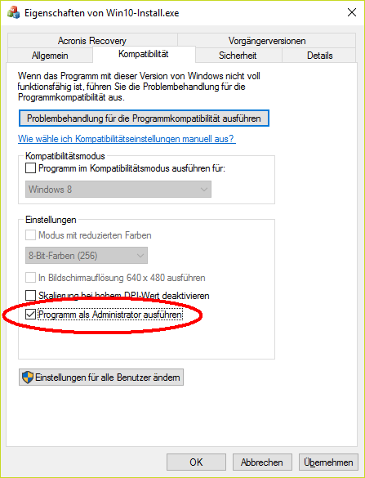Make sure ***D:\Radex\bin\WIN10-Install.exe*** is configured to run as Admin
3. Make sure RunOnce is set to Win10-Installer
   1. run Regegit.exe as Admin
   2. 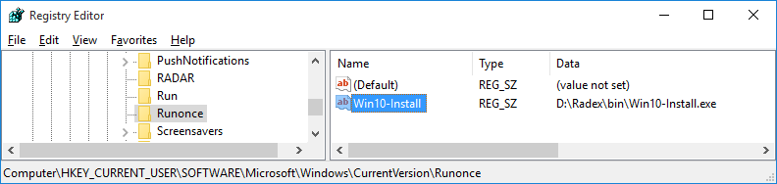Check the following setting:

4. Run Sysprep as Admin

1. Insert USB-Disk
2. Select “Reboot”
3. Start
4. Wait ……
5. Select “Record”